**Tag 1: <html>**

**Description:** Root element that defines the entire HTML document.

**Common Attributes:** lang, xmlns

**Code Snippet:**



**Output:** Doesn’t visibly affect the layout but contains all HTML code.

**Influence:** Essential for a valid HTML structure and for defining the document language.

**Tag 2: <head>**

**Description:** Contains metadata and links for the page (title, styles, etc.).

**Common Attributes:** None commonly used

**Code Snippet:**



**Output:** No visible output on the page.

**Influence:** Sets up information like title, character encoding, and styles.

**Tag 3: <title>**

**Description:** Sets the title in the browser tab.

**Common Attributes:** None

**Code Snippet:**



**Output:**



**Influence:** Improves usability and SEO.

**Tag 4: <meta>**

**Description:** Provides metadata about the HTML document.

**Common Attributes:** charset, name, content

**Code Snippet:**



**Output:** No visible output.

**Influence:** Ensures correct character rendering and SEO info.

**Tag 5: <h1>**

**Description:** Defines the largest heading.

**Common Attributes:** id, class, style

**Code Snippet:**



**Output:**

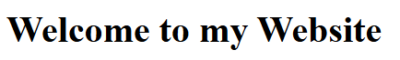

**Influence:** Marks the main heading of the page, improves structure.

**Tag 6: <h2>**

**Description:** Second level heading.

**Common Attributes:** id, class, style

**Code Snippet:**



**Output:**



**Influence:** Creates semantic hierarchy.

**Tag 7: <p>**

**Description:** Defines a paragraph.

**Common Attributes:** id, class, style, align

**Code Snippet:**



**Output:**



**Influence:** Structures readable content.

**Tag 8: <br>**

**Description:** Inserts a line break.

**Common Attributes:** None

**Code Snippet:**



**Output:** Line 2 appears on the next line.

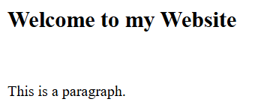

**Influence:** Improves text formatting.

**Tag 9: <hr>**

**Description:** Draws a horizontal line.

**Common Attributes:** style, width, color

**Code Snippet:**



**Output:** Renders a horizontal rule.



**Influence:** Visually separates content sections.

**Tag 10: <a>**

**Description:** Defines a hyperlink.

**Common Attributes:** href, target, rel, title

**Code Snippet:**



**Output:**  Clickable “Visit” link.



**Influence:** Enables navigation between pages.

**Tag 11: <img>**

**Description:** Embeds an image.

**Common Attributes:** src, alt, width, height

**Code Snippet:**



**Output:**

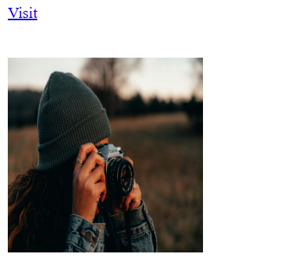

**Influence:** Adds visual elements.

**Tag 12: <ul>**

**Description:** Creates an unordered list.

**Common Attributes:** type, style

**Code Snippet:**



**Output:**



**Influence:** Organizes content.

**Tag 13: <ol>**

**Description:** Creates an ordered list.

**Common Attributes:** type, start, reversed

**Code Snippet:**



**Output:**



**Influence:** Adds structured, stepwise content.

**Tag 14: <li>**

**Description:** Defines a list item.

**Common Attributes:** value, type, style

**Code Snippet:**



**Output:**



**Influence:** Used in lists and menus.

**Tag 15: <div>**

**Description:** Generic container for content.

**Common Attributes:** id, class, style

**Code Snippet:**



**Output:** No default styling.

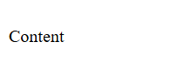

**Influence:** Used for layout and grouping.

**Tag 16: <span>**

**Description:** Inline container for text.

**Common Attributes:** id, class, style

**Code Snippet:**



**Output:** Text styled as red.



**Influence:**Styles small parts of content.

**Tag 17: <strong>**

**Description:** Defines important text.

**Common Attributes:** style, class

**Code Snippet:**



**Output:**



**Influence:** Adds semantic emphasis.

**Tag 18: <em>**

**Description:** Defines emphasized text.

**Common Attributes:** style, class

**Code Snippet:**



**Output:** Italic text.



**Influence:** Semantic for emphasis.

**Tag 19: <form>**

**Description:** Creates an input form.

**Common Attributes:** action, method, id

**Code Snippet:**

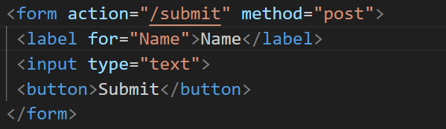

**Output:** Displays form elements.



**Influence:** Enables user input and interaction.

**Tag 20: <input>**

**Description:** Input field for form.

**Common Attributes:** type, name, value, placeholder

**Code Snippet:**



**Output:**



**Influence:** Collects user data.

**Tag 21: <label>**

**Description:** Defines label for form element.

**Common Attributes:** for, id

**Code Snippet:**



**Output:** Text label linked to input.



**Influence:** Improves accessibility and UX.

**Tag 22: <button>**

**Description:** Clickable button.

**Common Attributes:** type, onclick

**Code Snippet:**



**Output:** Displays a button.



**Influence:** Handles user actions.

**Tag 23: <select>**

**Description:** Drop-down menu.

**Common Attributes:** name, multiple

**Code Snippet:**

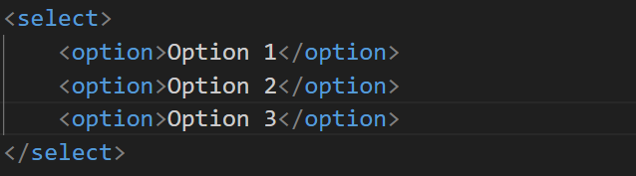

**Output:** Drop-down selector.



**Influence:** Offers multiple options in forms.

**Tag 24: <option>**

**Description:** Defines an option in a drop-down.

**Common Attributes:** value, selected

**Code Snippet:**



**Output:** Selectable item.



**Influence:** Defines selectable choices.

**Tag 25: <textarea>**

**Description:** Multi-line text input.

**Common Attributes:** rows, cols, placeholder

**Code Snippet:**

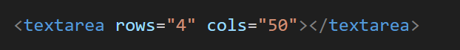

**Output:** Text box with multiple lines.

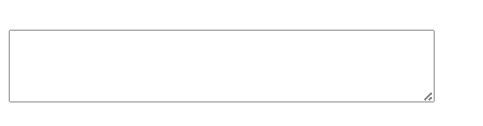

**Influence:** Accepts longer input.

**Tag 26: <table>**

**Description:** Creates a table layout.

**Common Attributes:** border, cellspacing

**Code Snippet:**

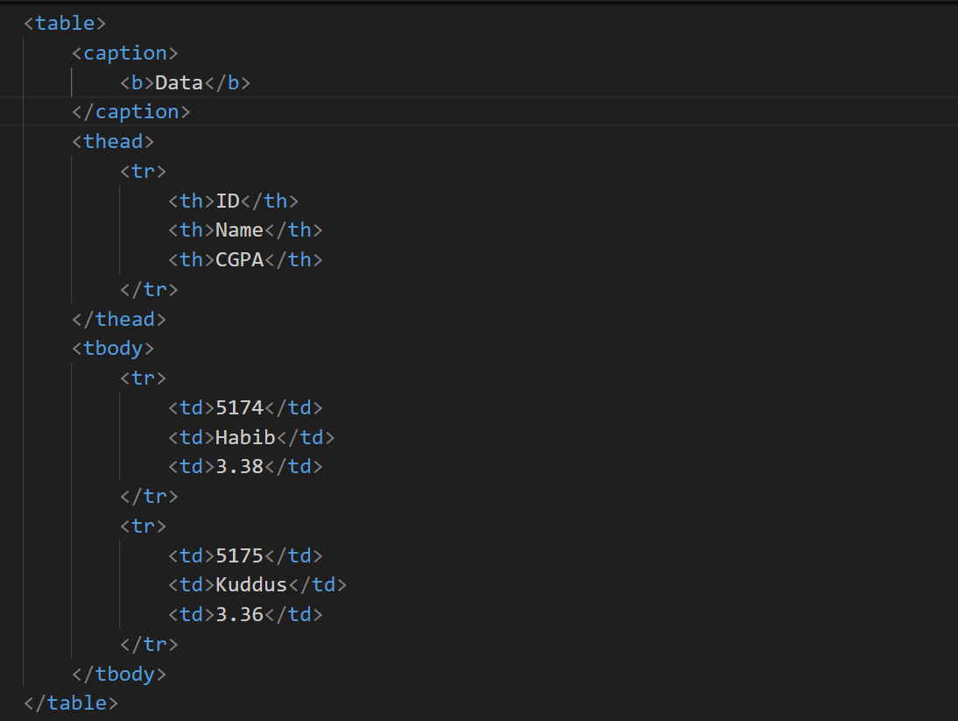

**Output:**

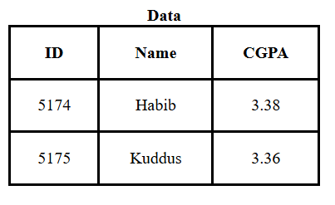

**Influence:** Organizes data.

**Tag 27: <tr>**

**Description:** Defines a table row.

**Common Attributes:** None commonly used

**Code Snippet:**



**Output:**



**Influence:** Groups cells horizontally.

**Tag 28: <td>**

**Description:** Defines table data cell.

**Common Attributes:** colspan, rowspan

**Code Snippet:**



**Output:**



**Influence:** Displays data in tables.

**Tag 29: <th>**

**Description:** Table header cell.

**Common Attributes:** scope

**Code Snippet:**



**Output:**



**Influence:** Labels columns or rows.

**Tag 30: <footer>**

**Description:** Defines footer section.

**Common Attributes:** id, class

**Code Snippet:**



**Output:** Displays text at the bottom.



**Influence:** Concludes page content.